Whalers Kaanapali Beach SharePoint Site Deployment Guide Instructions
Non-Microsoft Email
If using a non-Microsoft email address (i.e. @icloud.com, @yahoo.com, @gmail.com, …) the process will be like this:

- Click on “Accept Invitation” link in the email you received (Check spam folder if they do not see it).
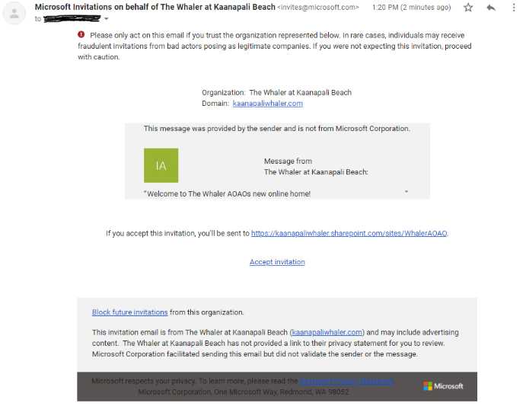

- You will be prompted to create a Microsoft account. Click Next.
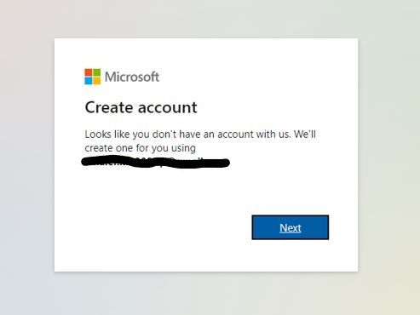

- Create a memorable password. Click Next.
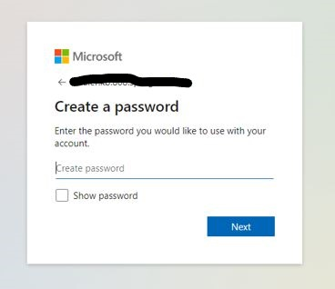

- Select your country/region and enter your birthdate using the dropdown menus. Click Next.
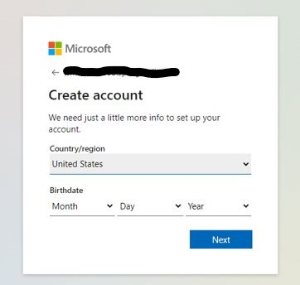

- Enter the code sent to the email account listed in the prompt and uncheck the box (Check spam folder). Click Next.
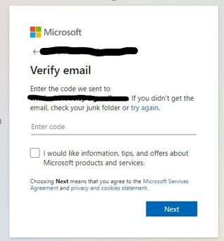

- Review the access permissions and click Accept.
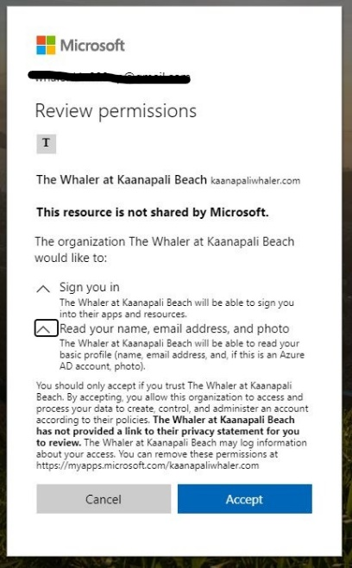

- You will then receive a prompt stating that more information is required. Click Next.
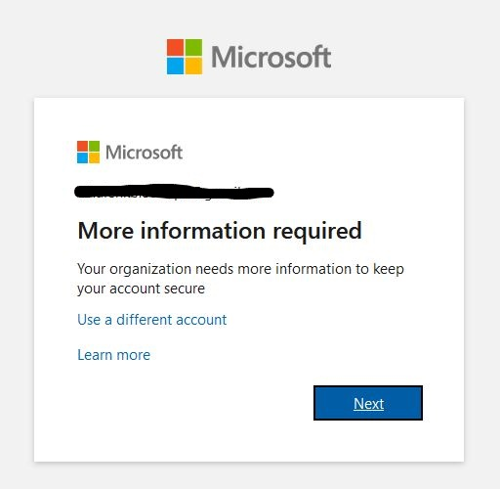

- To setup your Multi Factor Authentication select “Authentication phone”. Select your country code and enter your phone number, including area code, in the text box.
  - For text verification select “Send me a code by text message”
  - Click Next
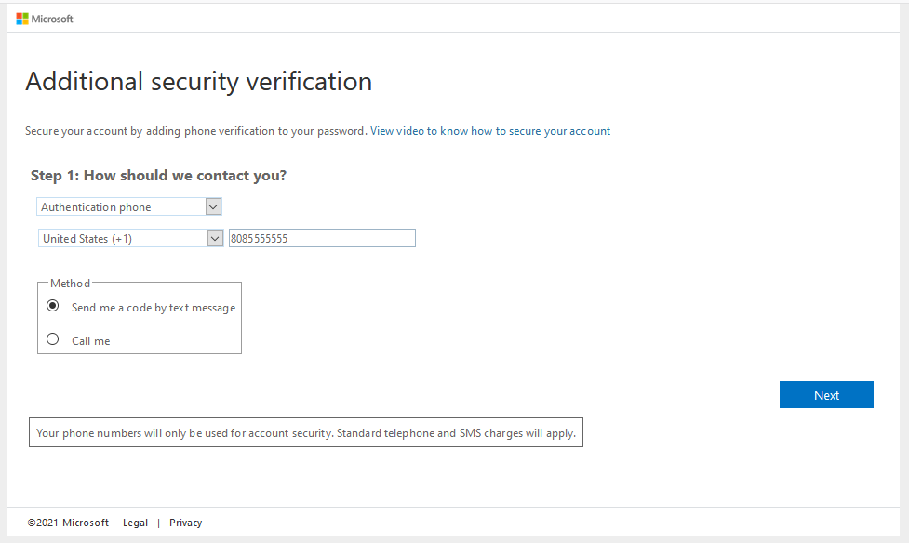

- Enter the 6-digit code you receive in a text on the phone number you entered on the previous page. Click Verify.
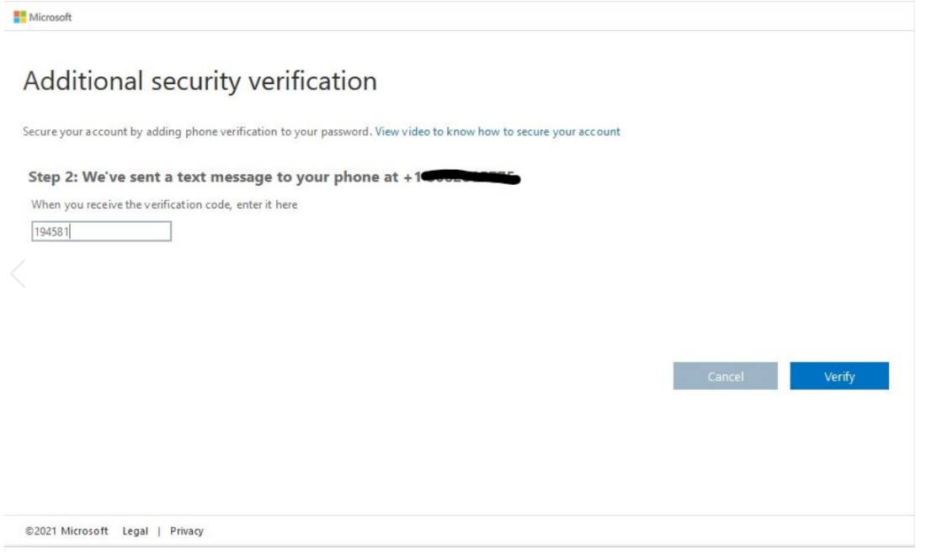

- You will receive a message of “Verification successful!”. Click Done.
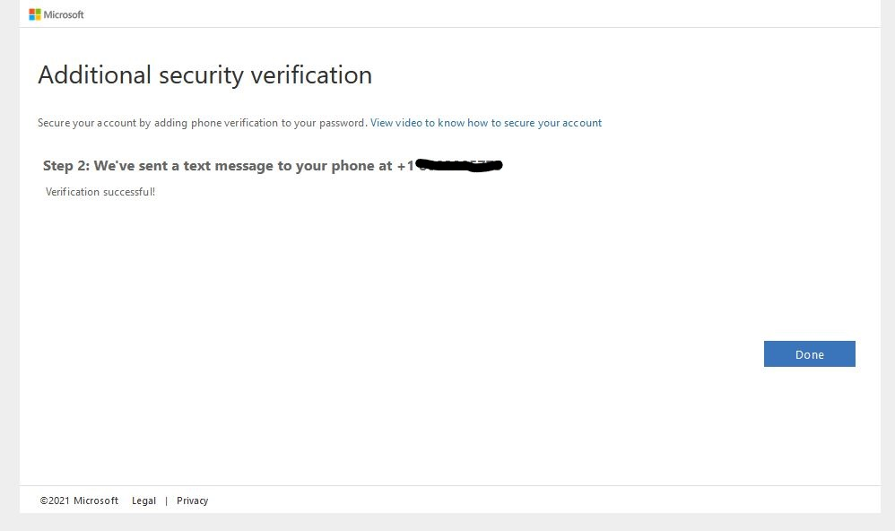

- Once processed, you will be brought to the new homepage of the AOAO Owner’s website. Make sure to bookmark this site as the old site will be shut down soon. Account setup is now complete!
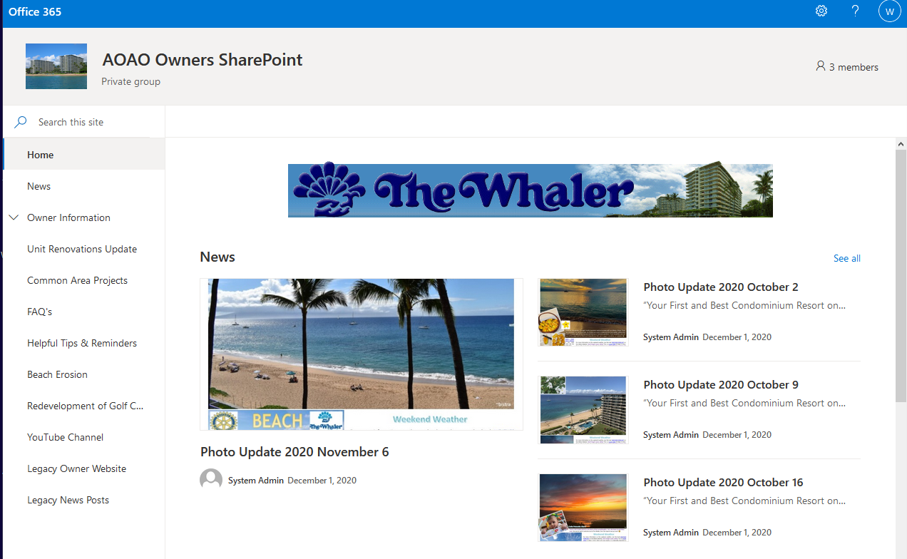

Using a Microsoft Account/Email

If using a Microsoft email address (i.e. @outlook.com, @live.com, @hotmail.com, …), their process will be like this:

- Click the “Accept Invitation” link in the email you received (Check spam folder if they do not see it).
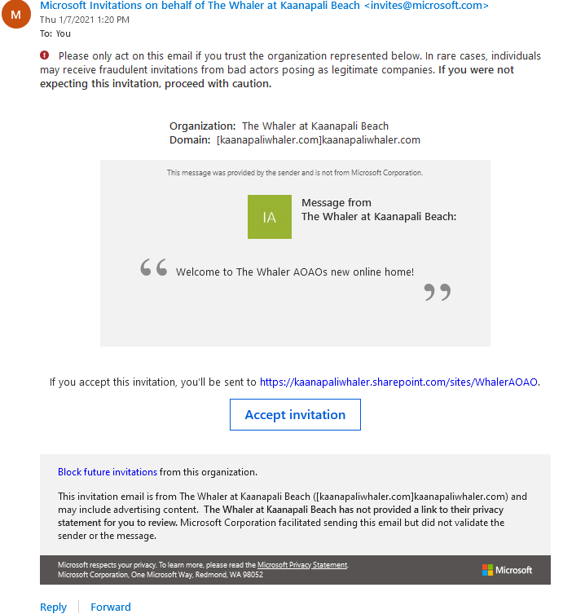

- Review the access permissions and click Accept.
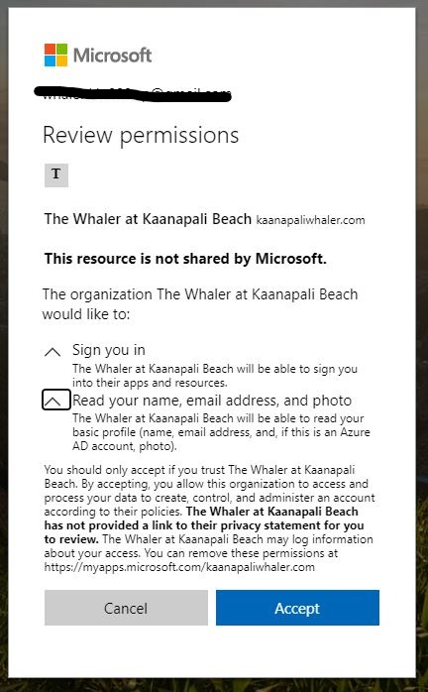

- You will then receive a prompt stating more information is required. Click Next.

- To setup your Multi Factor Authentication select “Authentication phone”. Select your country code and enter your phone number, including area code, in the text box.
  - For text verification select “Send me a code by text message”
  - Click Next.

- Enter the 6-digit code you receive in a text on the phone number you entered on the previous page. Click Verify.
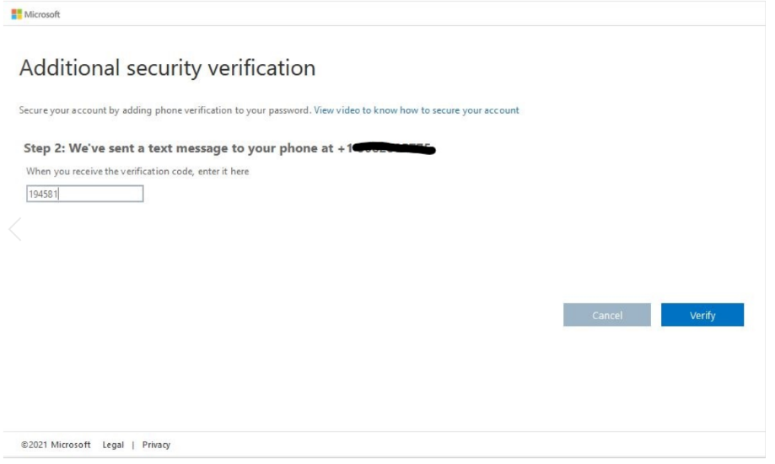

- You will receive a message of “Verification successful!”. Click Done.
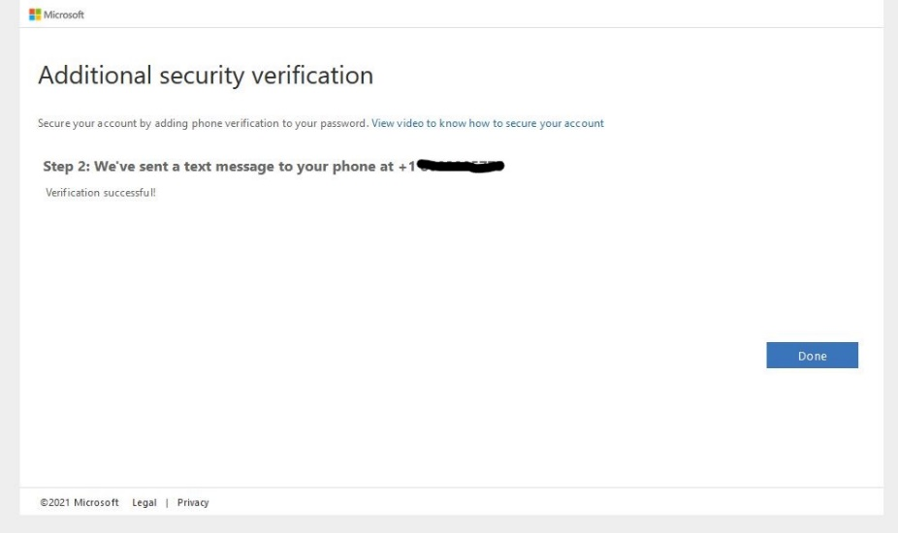

- Once processed, you will be brought to the new homepage of the AOAO Owner’s website. Make sure to bookmark this site as the old site will be shut down soon. Account setup is now complete!
